Symbol Binary | Left | Center | Right | NOTES
25 | X | X | X | Top of strip – right strip
24 | 7 | X | 7 | Top of strip – center strip and left strip
23 | X | C | X
22 | 1 | X | 2
21 | X | 1 | X
20 | 2 | X | 1
19 | X | 2 | X
18 | 3 | X | 3
17 | X | 7 | X | 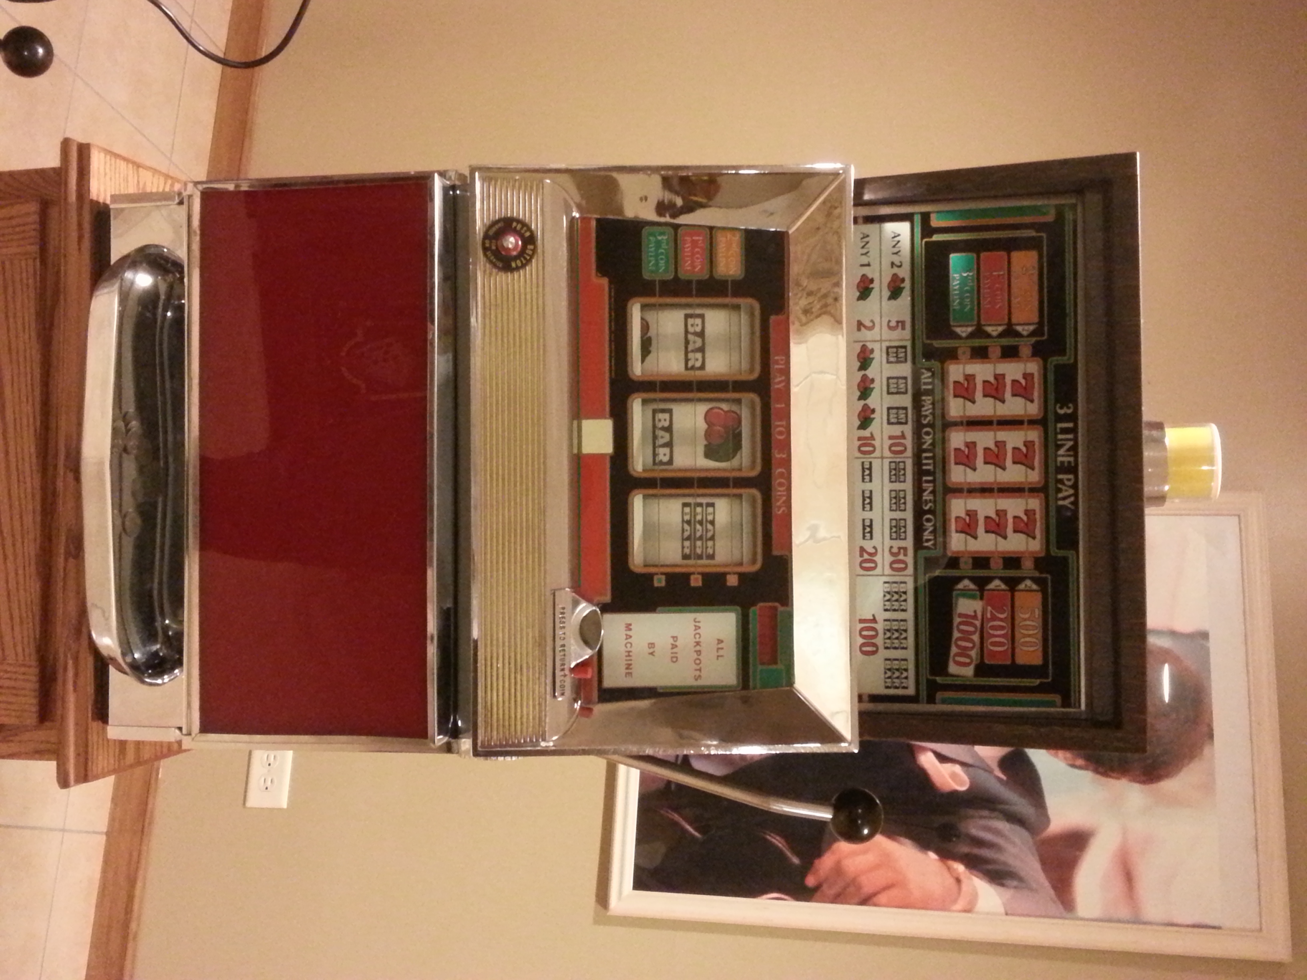
16 | X | X | X
15 | 1 | X | C
14 | X | 3 | X
13 | C | X | 1
12 | X | 1 | X
11 | 1 | X | 3
10 | X | 2 | X
9 | X | X | X
8 | 3 | X | 1
7 | X | C | X
6 | 1 | X | 2
5 | X | 1 | X
4 | 2 | X | 1
3 | X | 2 | X
2 | 1 | X | 3
1 | X | 1 | X | Bottom of strip
Machine Model  E-2224-30-2 |  | M1 |  | M2 |  | M3 |  | P1 |  | P2
 |  | E755-80 |  | E755-47 |  | E755-48 |  | 450489 |  | ---
Symbol Values
Original Strip | Single Bar = 1 |  | Double Bar = 2 |  | Triple Bar = 3 |  | Cherry – C |  | Blank = X |  | 7’s = 7
New Layout
This machine is a narrow body, 25-stop, 3-line pay, 3-coin
Set strip into reel bottom first; rotate reel downwards, top of strip will overlap bottom. Length of strip:___________
1
25
X

Top of reel strip is binary Bottom of strip is binary Strips are wide s Strips are narrow

