Maintaining your Bally Slot Machine
This slot machine, known as the E2000 series electro-mechanical slot, was originally placed in a casino, and has many hours of use on it. Built in 1983, it is over 25 years old and is fully legal for personal, home use. It has been reconditioned and brought back to its original specifications, and will provide hours of entertainment in your home. Old slot machines have a certain mystique about them. Your guests will enjoy inserting coins, pulling the handle, and hearing the winning coins hit the coin tray. Current-day slot machines no longer use the handle, and have gotten away from coin use, which makes these older machines more fun to play. Typically, the payout rate is around 85-90% of coins played and the big jackpot can hit at any time.
Normal use (as with any mechanical device) requires occasional maintenance, mostly keeping the machine clean and the mechanisms oiled. The following will outline some of the usual maintenance, and will define “error codes” that help diagnose conditions that may affect the operation of the machine. The error codes are displayed on the Win Meter, the red LED display on the right side of the machine. Every payout will display the quantity of coins won on the Win Meter. There is a soldered-in battery on the Microprocessor Unit (MPU) board that maintains the last win on the meter, even when the machine is shut off. This battery will last for years, but eventually will need to be replaced. A common replacement battery is an inexpensive, 3.6 volt NiMH cordless phone battery which can be soldered directly to the MPU circuit board.
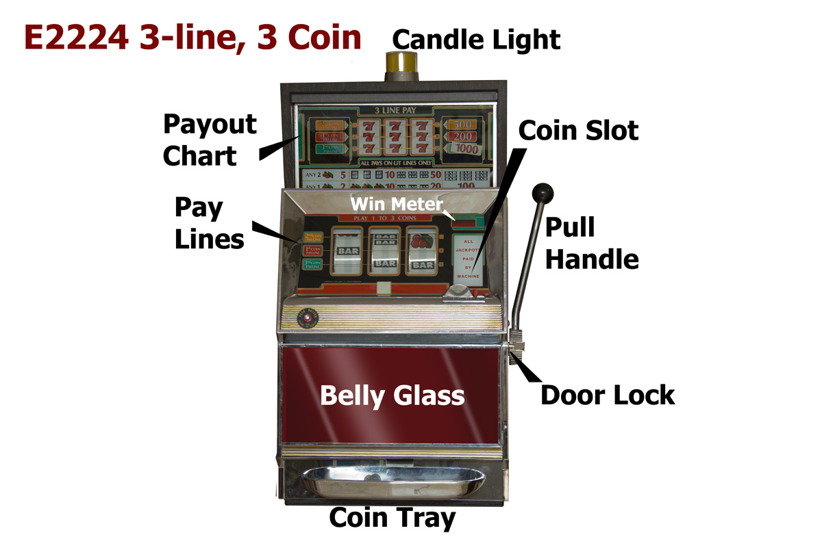

Here is a typical 3-line, 3 coin machine (E2224 shown). Turning the door lock key allows the front door to be swung open on its hinges, revealing the interior of the machine and all its workings. You can then access the coins in the coin hopper, remove the reel assembly, check for coin jams in the coin path, and have complete access to the internal parts of the machine. The section directly under the reel symbols will light up to tell you one of three things; Tilt, Coin Accepted and Insert Coin. When you first start the machine, you should see the “Insert Coin” panel illuminated. Once you insert your coin or coins, the “Coin Accepted” panel lights up, and when you have reached the maximum number of coins to be played, the Coin Accepted light goes out. If there is a coin jam or other error, the “Tilt” panel lights up and you will need to correct the fault, and then press the Reset button on the coin hopper mechanism. The Insert Coin light will then illuminate, allowing you to play the machine.
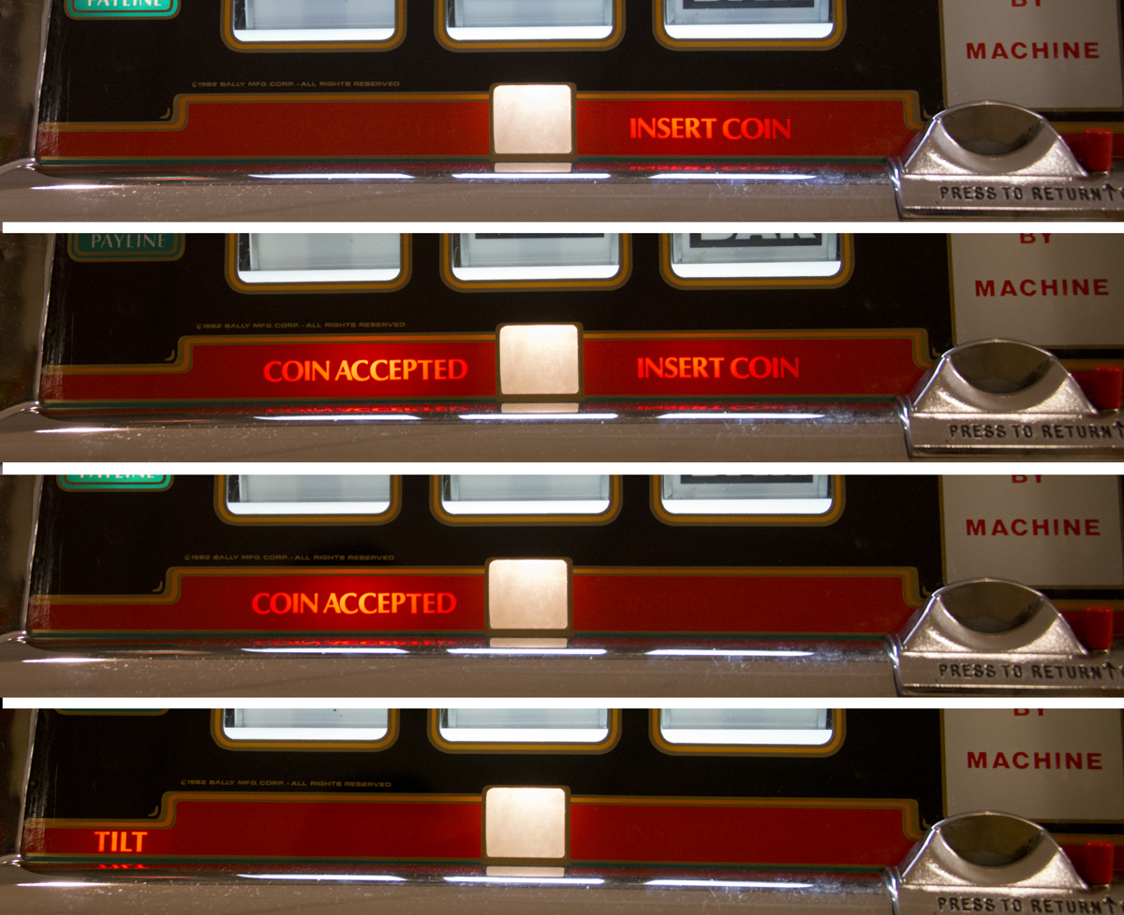

Let’s discuss the basic operation of a slot machine. When the coin enters the coin slot, it travels thru a chute to a device called a coin comparitor, which determines that the coin you inserted is the proper coin. The comparitor has a spring-loaded clamping mechanism on it, and holds a sample of the coin you are using; in the image below, you can see the US quarter in its holder. The comparitor looks at each coin that is played, and compares it to the coin in the holder. If it’s the same, the coin played is then routed thru a switch, and into the coin hopper. The machine then registers a coin played when it contacts the Coin In switch, and each coin played will light a payout line on the front of the machine. If an incorrect or different coin or token is played, the comparitor rejects it and sends it into the coin tray instead of the Coin Hopper. Note that a wrong size coin in the hopper could cause a coin-feed jam and should be avoided.
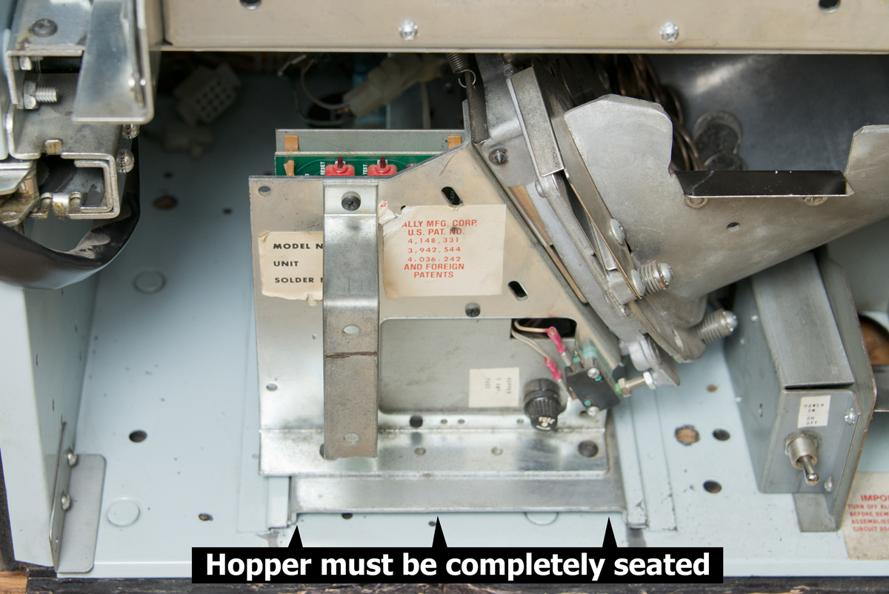
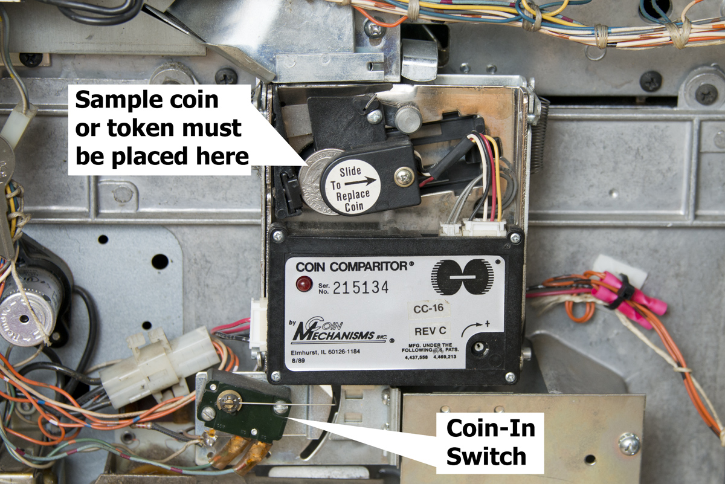

The coin hopper fills up with coins played, and is the “bank” that stores the coins for future payouts. In a casino environment, once the hopper fills completely, a switch on the hopper mechanism senses the weight of the coins and causes any played coins to be diverted to a chute that sends the coins into the cabinet base which the machine sits on. The coins collected in the machine base are the earnings for the casino. Since your home-use machine wouldn’t ever see large quantities of coins, and you will re-use any coins or tokens you are playing with, the coin-to-base diverter has been disabled. Basically, you fill the machine with maybe 300-500 coins and occasionally open the front door to recycle the coins from the hopper bowl to be played again. Most home use machine owners keep several coins in the coin tray, or in a cup outside of the machine. These are the coins you and your guests will use to play the machine. Note that if you remove the hopper, you must then return it to its fully inserted position. There is a floating electrical connector on the rear of the hopper that connects the electronics to the rest of the machine, and must be fully engaged.
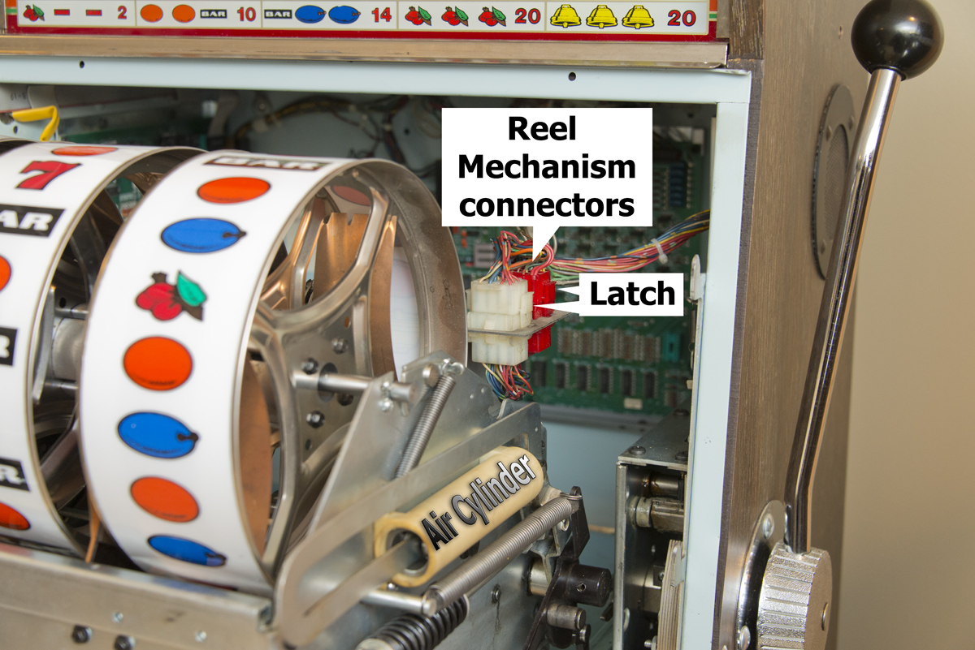
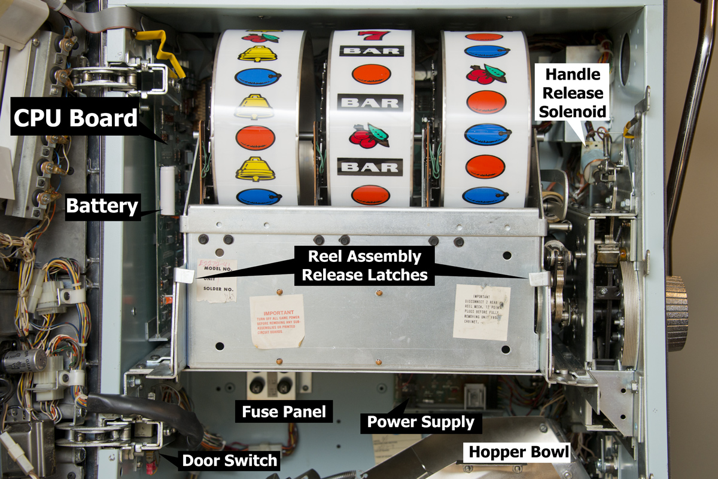

Looking at the reel assembly, maintenance lubrication can be performed easily by removing the entire assembly. There are two release latches as shown. Pivot these two latches downward so that they are perpendicular to the assembly, and pull partially out of the machine. Note the two electrical connectors, one white and one red, which need to be released from their connections by squeezing the latches and pulling the connectors from their mating receptacle. The reel assembly can then be removed from the machine. Below is a guide for lubrication of moving parts.
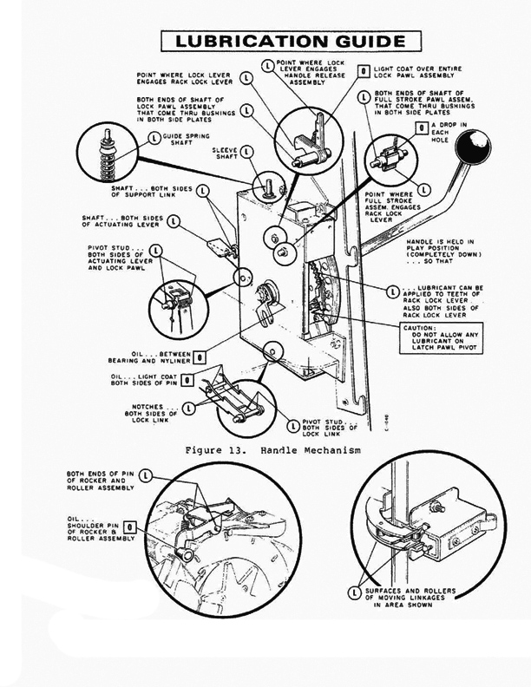
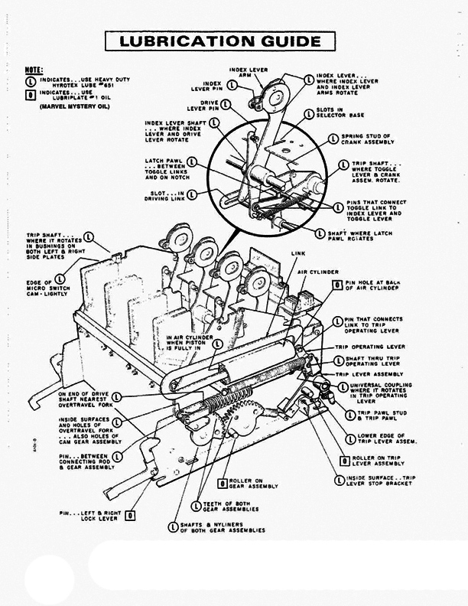

Game Malfunction Codes
This slot machine is built for reliability and consistent use. It has been in operation for thousands of hours and because it was designed to be a profit maker for the casino in which it was installed, so its design must be rugged and dependable. Home use, however, sees much less day-to-day use, and oddly, when the machine sits unused, sometimes errors start to happen. For example, the battery on the MPU circuit board will eventually discharge and cause data loss. This happens because the battery is normally constantly trickle-charging when the machine is powered up. When it’s unplugged, however, the battery slowly discharges. Leaving the machine on for hours will keep the battery fully charged. Your machine has been fitted with an oversized, Lithium-Ion battery for years of dependable use.
Note that the grease and oil on the moving parts tend to dry out or run off, necessitating the need for fresh lubrication. And, dust, dirt, and even spider webs will collect in odd places, causing problems as well.
Bally provided a means to troubleshoot a malfunctioning machine by way of the Coin Win Meter display, using it to spell out malfunction codes. It does this by presenting a two-digit code that corresponds to a specific error. Below is The Bally instruction set relative to those malfunction codes. You can test the machine for error codes, one step at a time, using the TEST button located on the hopper mechanism PC board.
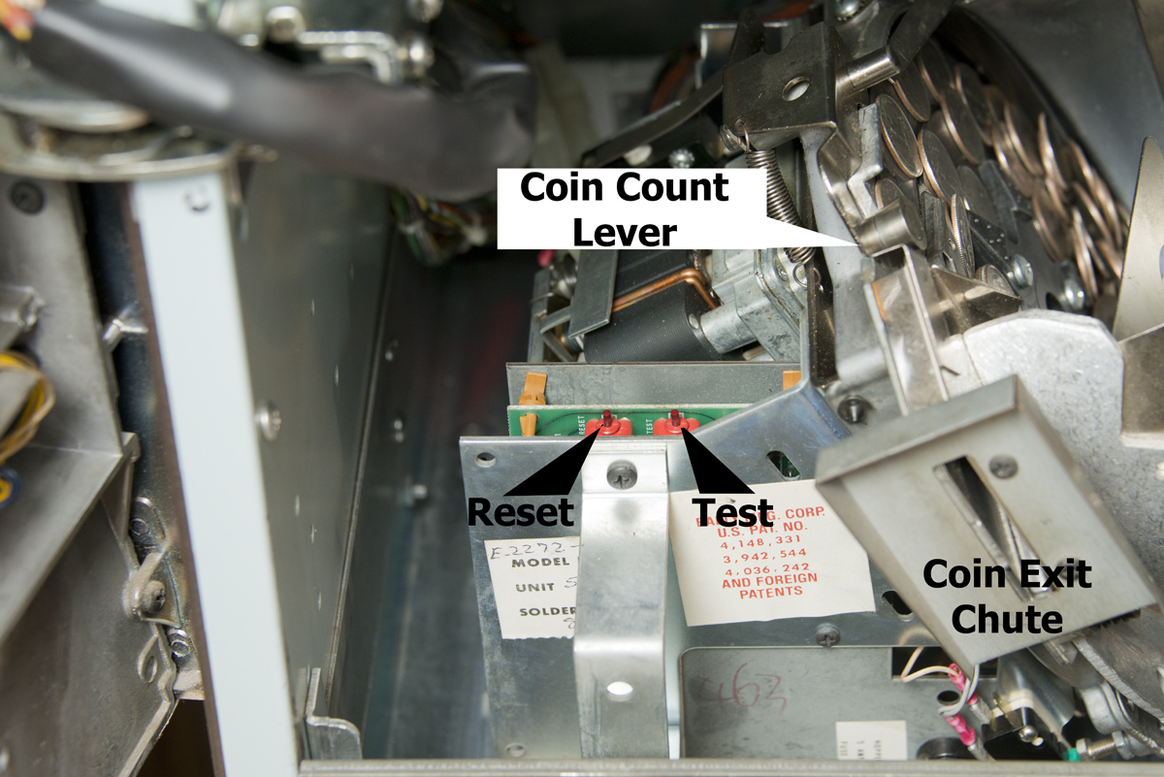

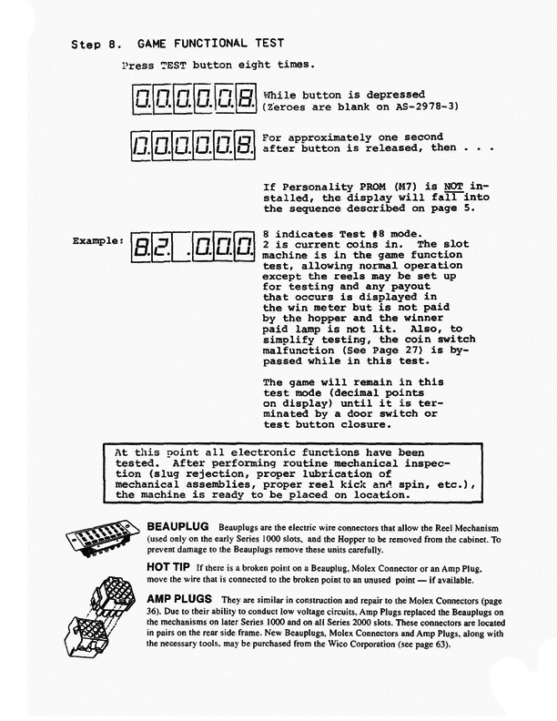
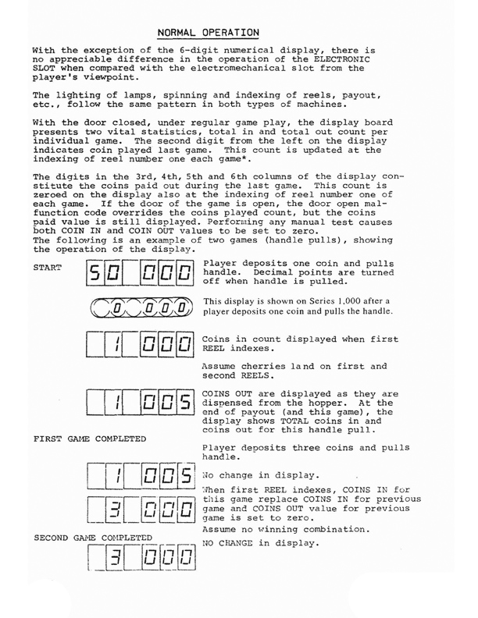

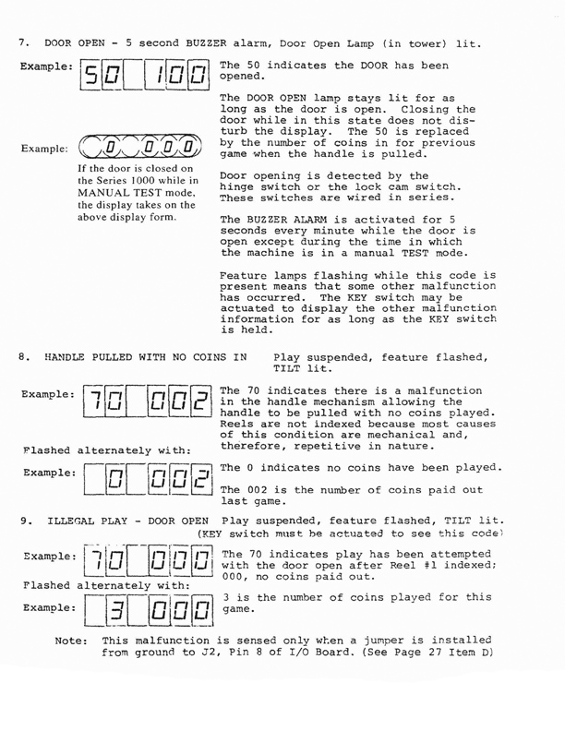
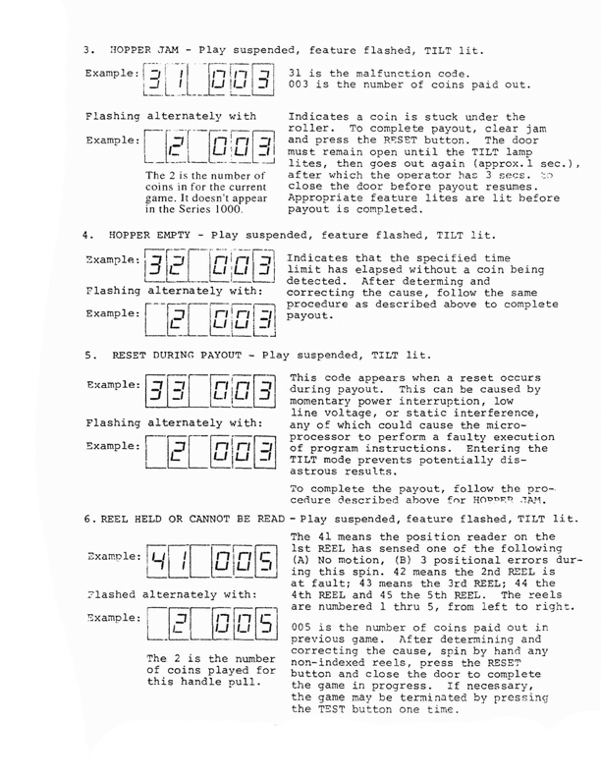
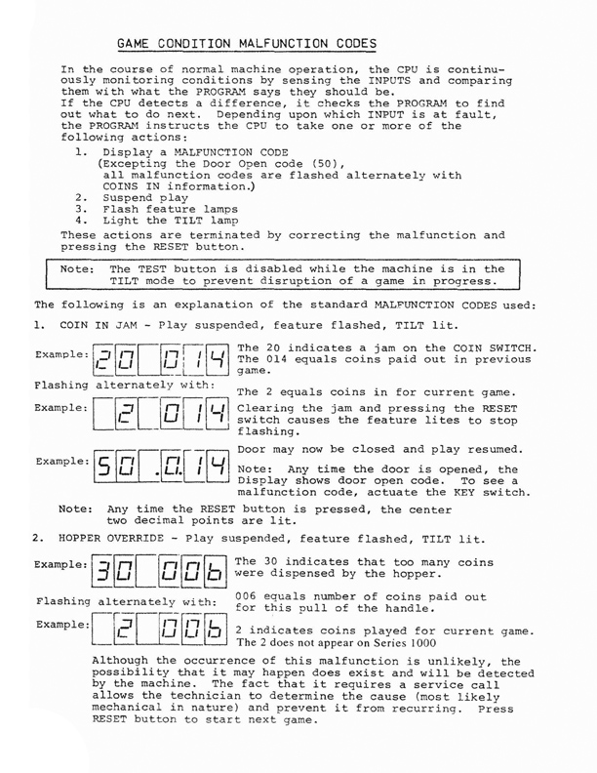
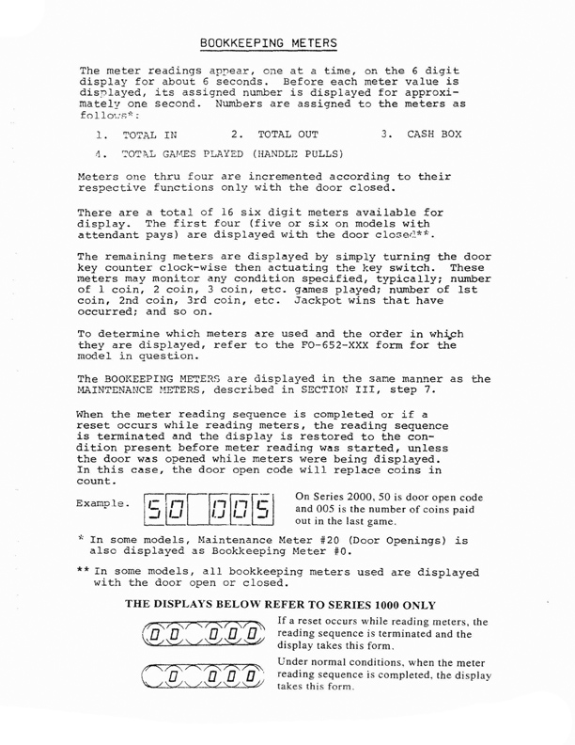

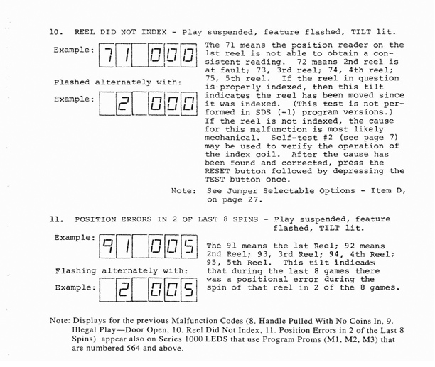

Portions of this document Copyright ©Bally Gaming, Inc.
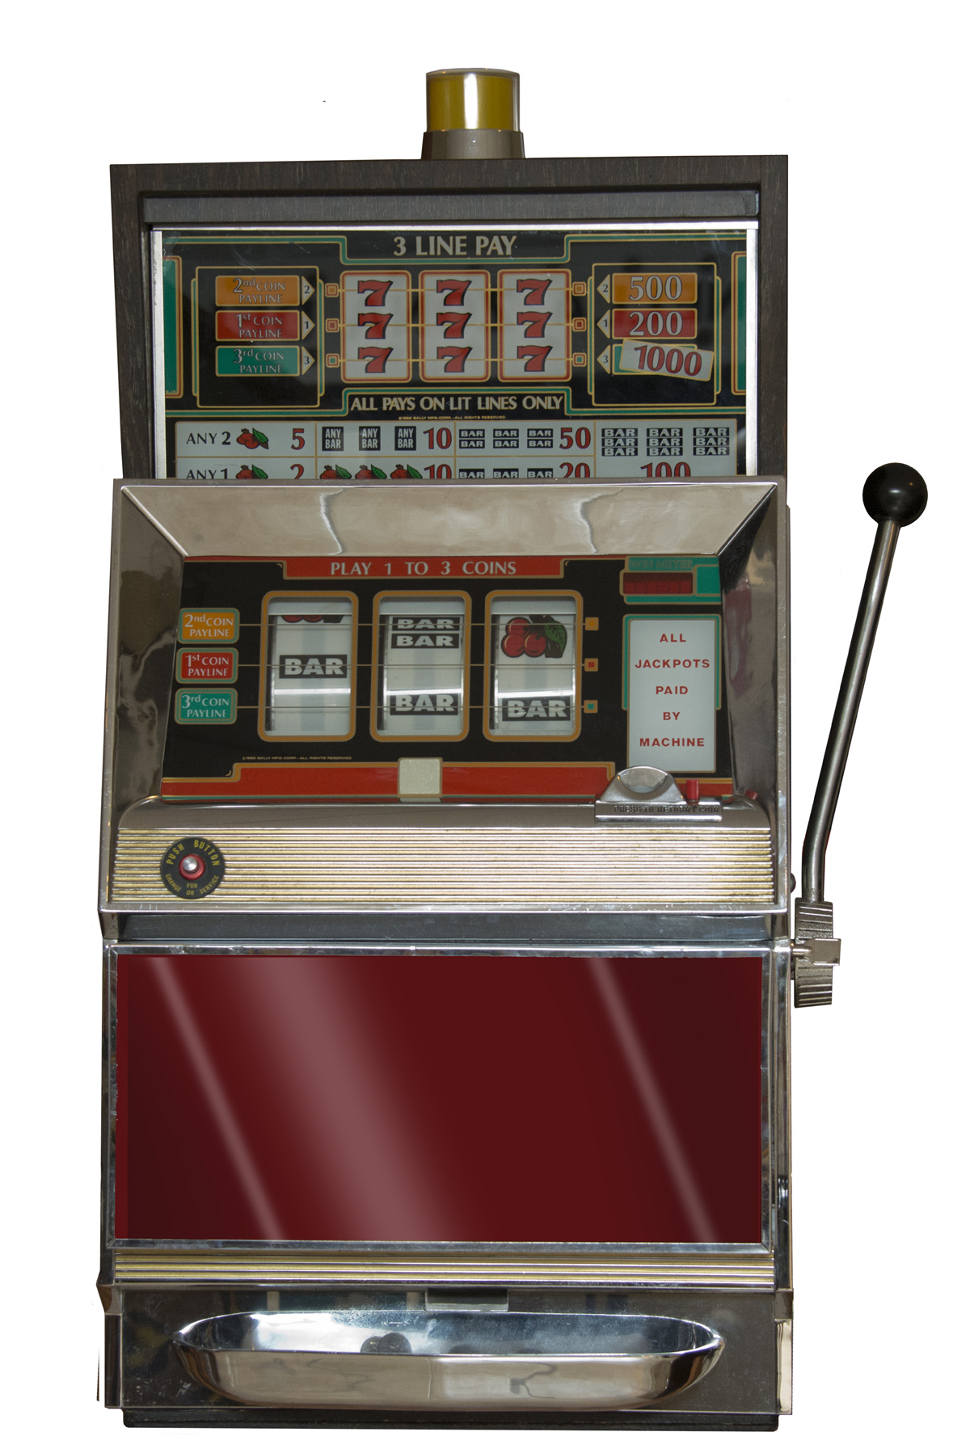
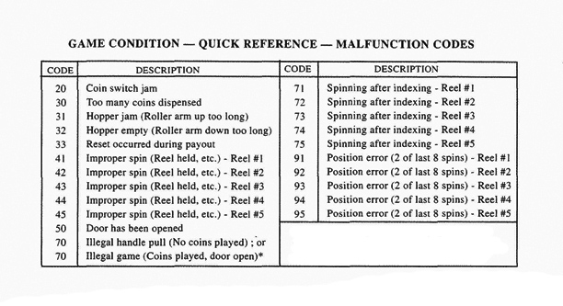

What’s Inside the Bally E Series Machine?
Look inside the front door to reveal the internal workings of the machine. Shown below are views of the fluorescent lighting ballasts and their starters. Typically there are three fluorescent lamps on the door assembly.
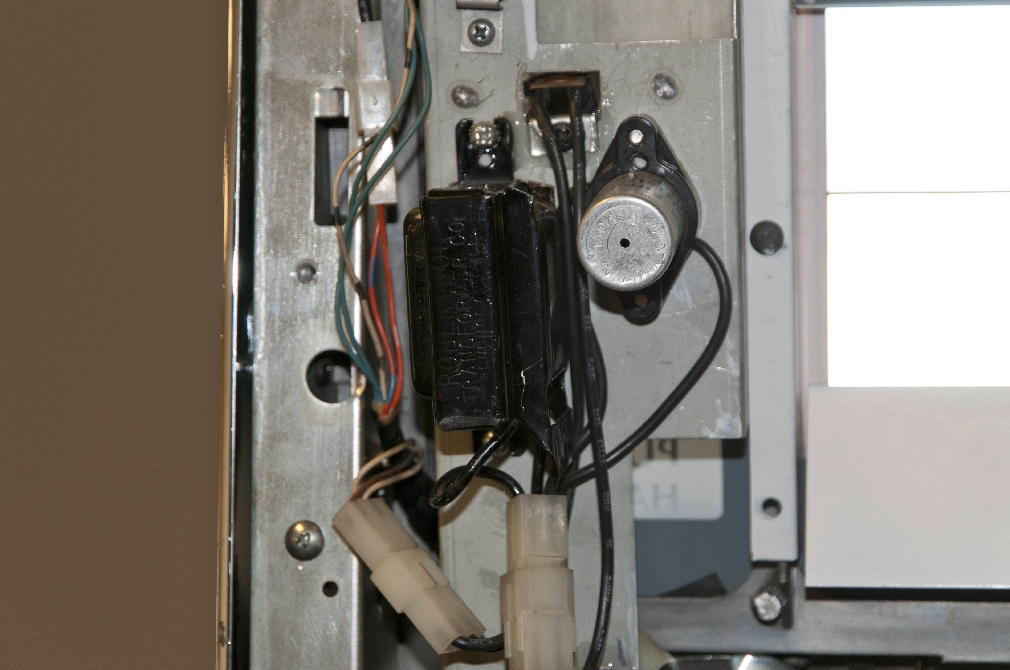
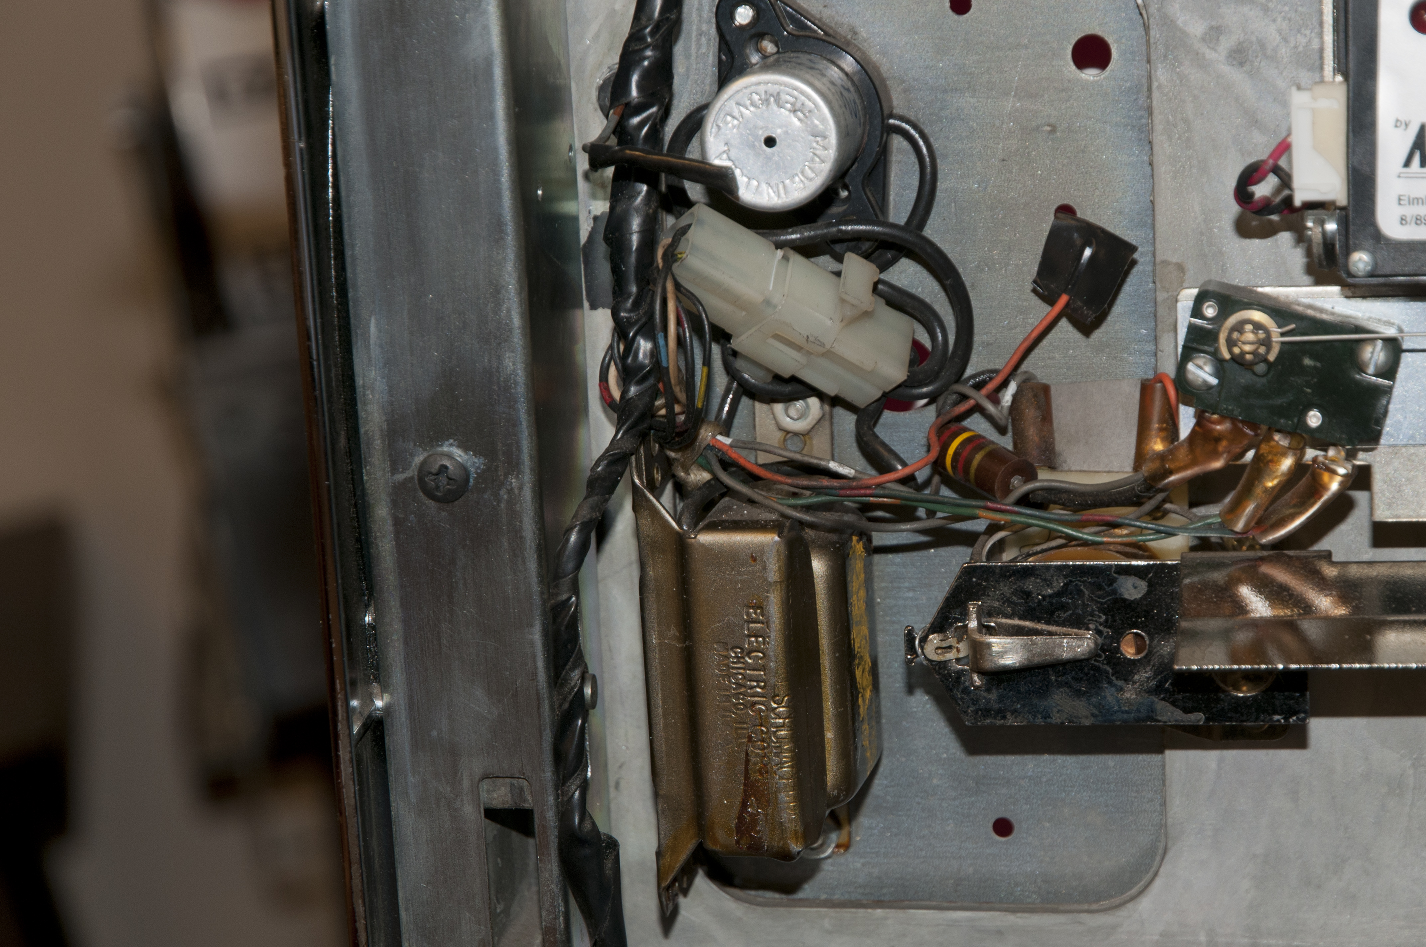
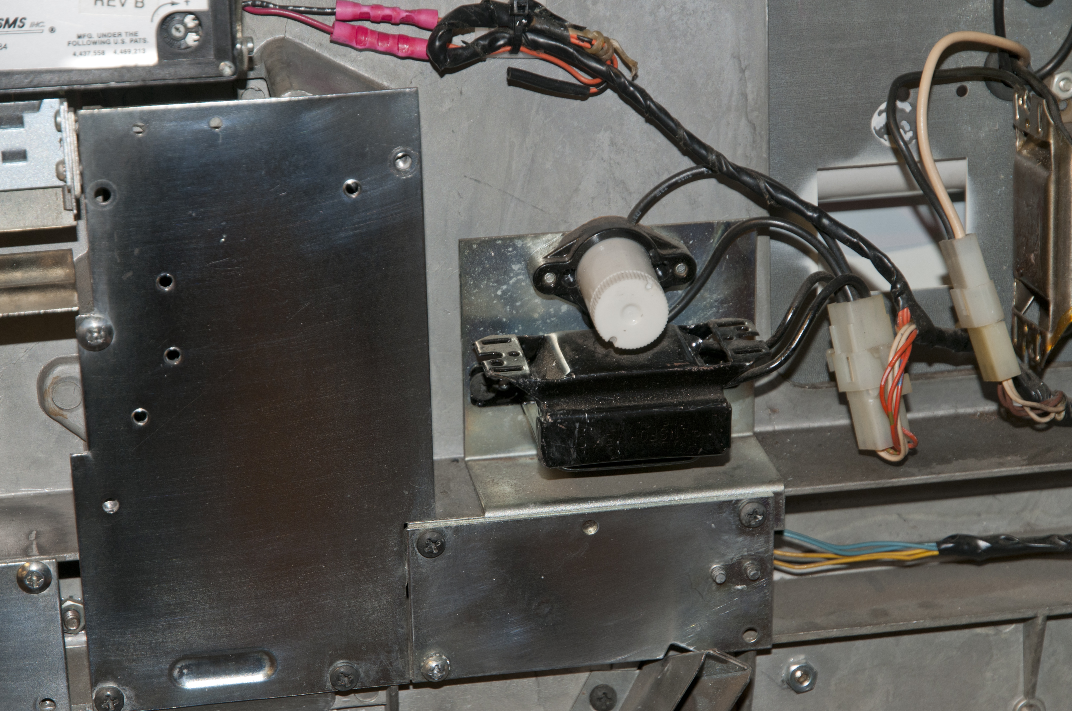

Shown here is the coin diverter solenoid that has been modified to channel the coins exiting the comparitor into the hopper. The casino machine originally has a separate coin chute and would channel overflow coins into the base below the machine. The diverter would do this when the hopper was filled to capacity. But since your home-use game room machine will never have a full hopper, it serves no purpose and has been permanently removed from the machine. One of the solenoid wires has been cut and taped.
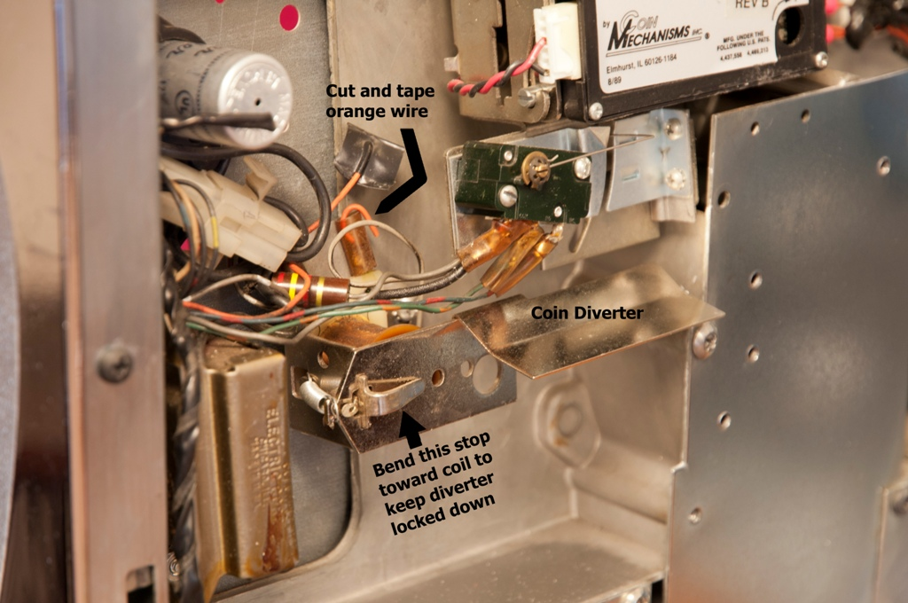

Adjacent to the handle, the mechanism shown here is responsible for allowing a handle pull. The handle pull won’t spin the reels unless a coin is in play. The Handle Release Solenoid is responsible for allowing the pull to initiate spinning of the reels. When the CPU (processor circuitry) verifies that coins are inserted, the solenoid pulls in, allowing the handle to connect with the reel assembly and commence spinning. Shown in the background is a cooling fan and a door buzzer which has been removed.
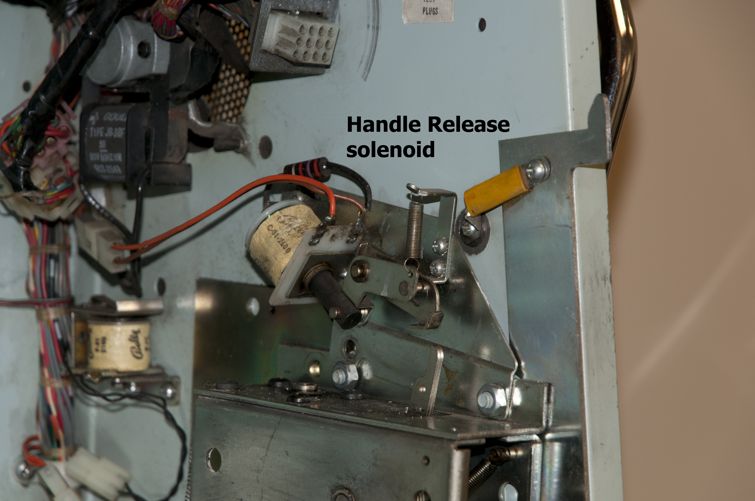

The CPU board is on the left side of the cabinet, next to the reels. This circuit controls the slot, determines payout, interfaces with all electrical controls, and provides information to the WIN meter. It also keeps track of coins paid out and incorporates circuitry called a Random Number Generator (RNG) which provides any one of several thousand possible symbol combinations for reel wins or losses. So, when you play the machine, where the reel symbols stop is determined the instant you pull the handle, and the CPU faithfully causes the reels to stop in their randomly determined position.
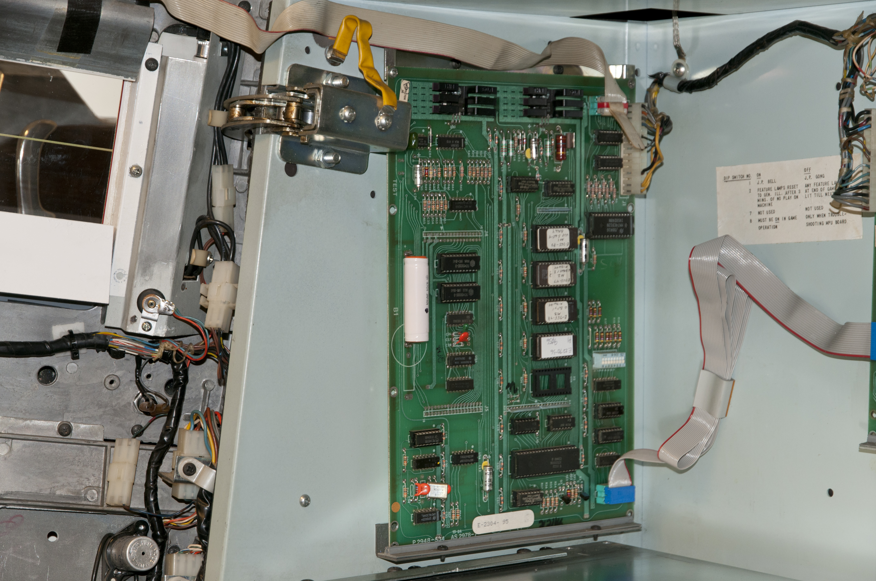

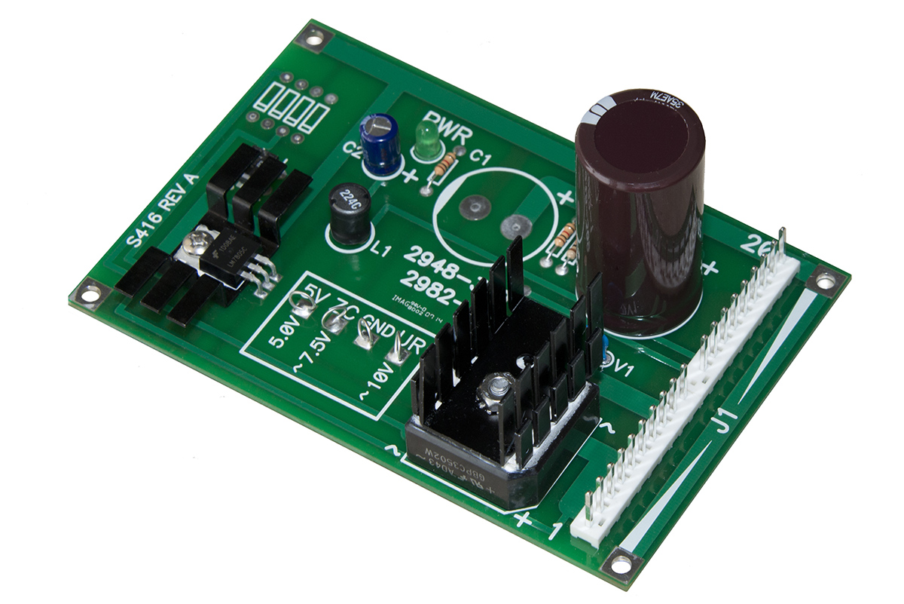
Here is the power supply found in your machine, behind the coin hopper. This is responsible for providing electrical power to the CPU, I/O, and all incandescent lamps. This new design replaces the original power supply, and this circuit will provide years of reliability due to its new robust design.

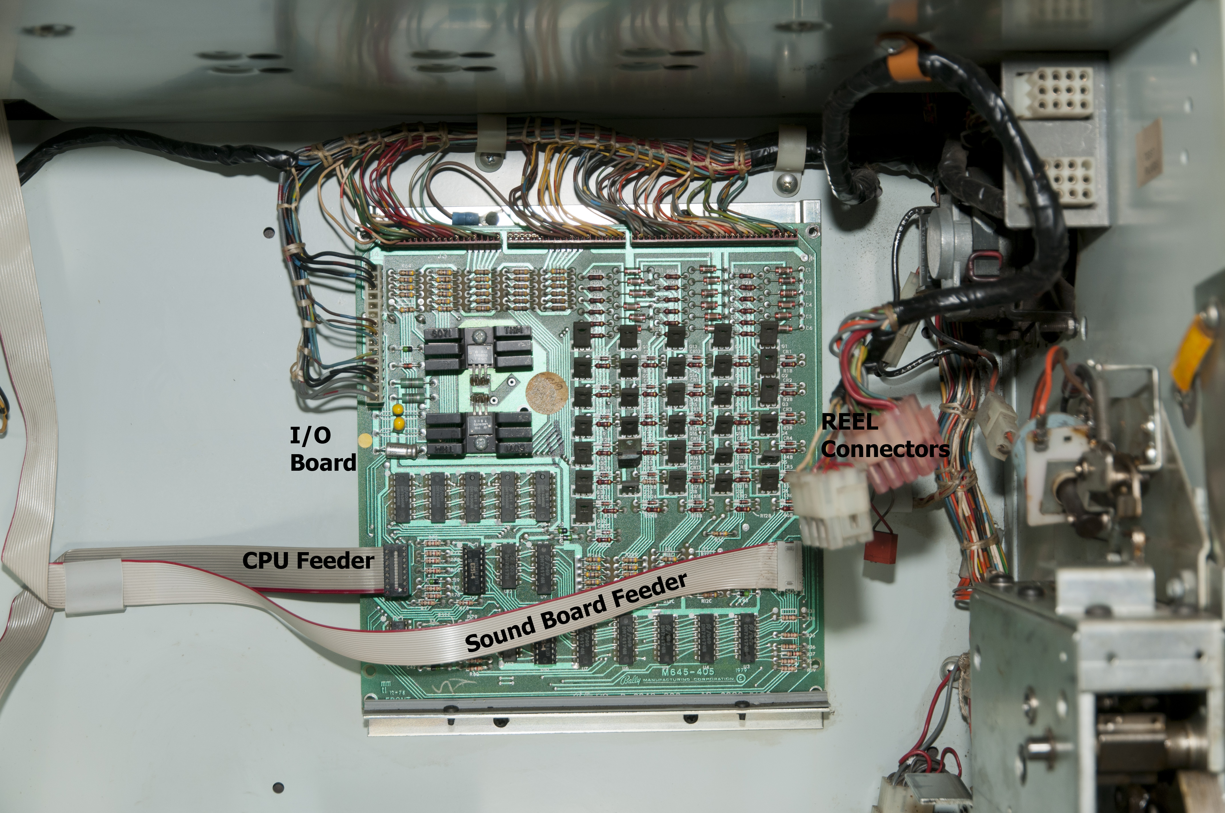
This is known as the I/O Board. Its job is to control all of the solenoids, lights, and switches in the machine. It gets its instructions from the CPU controller. You can find this board mounted to the inside back wall behind the reel mechanism.

Shown here is the door switch. It is found directly behind the upper door hinge. Its job is to tell the CPU if the slot machine door is open or closed. When the door is open, the machine won’t work properly. The switch is there as a safeguard so that the machine will operate normally only when the door is closed and locked. When the door is open and closed again, the WIN meter will indicate a “50” on the left telling the player that the door has been opened between plays.
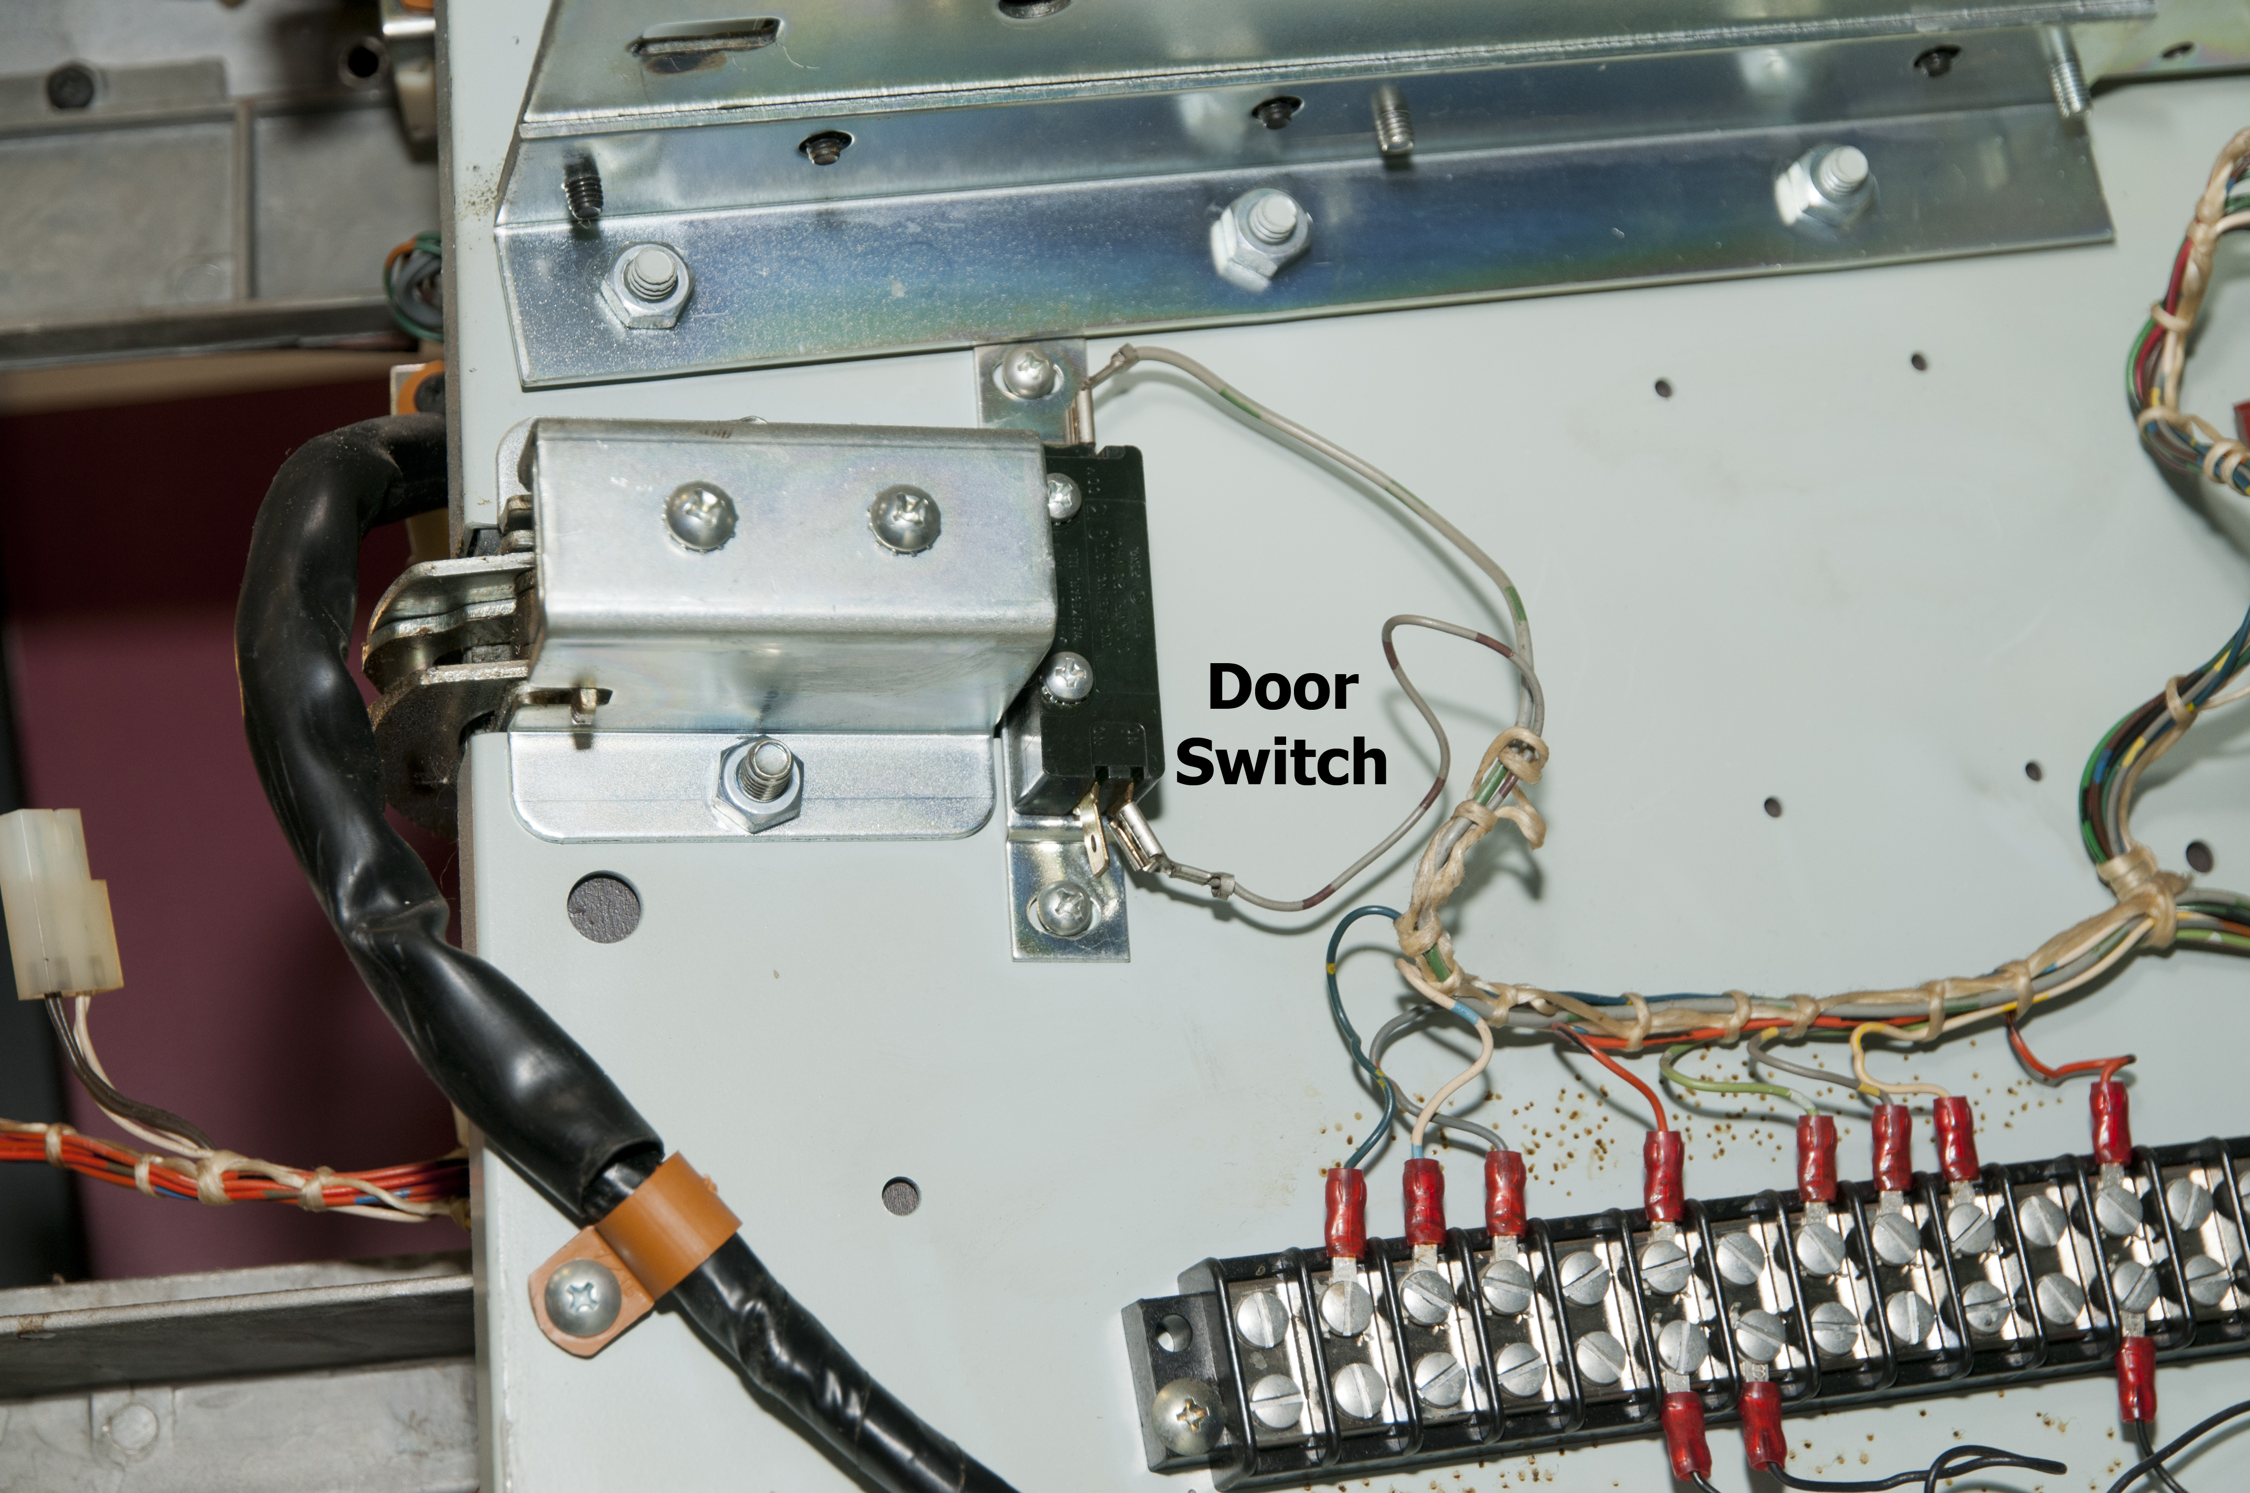

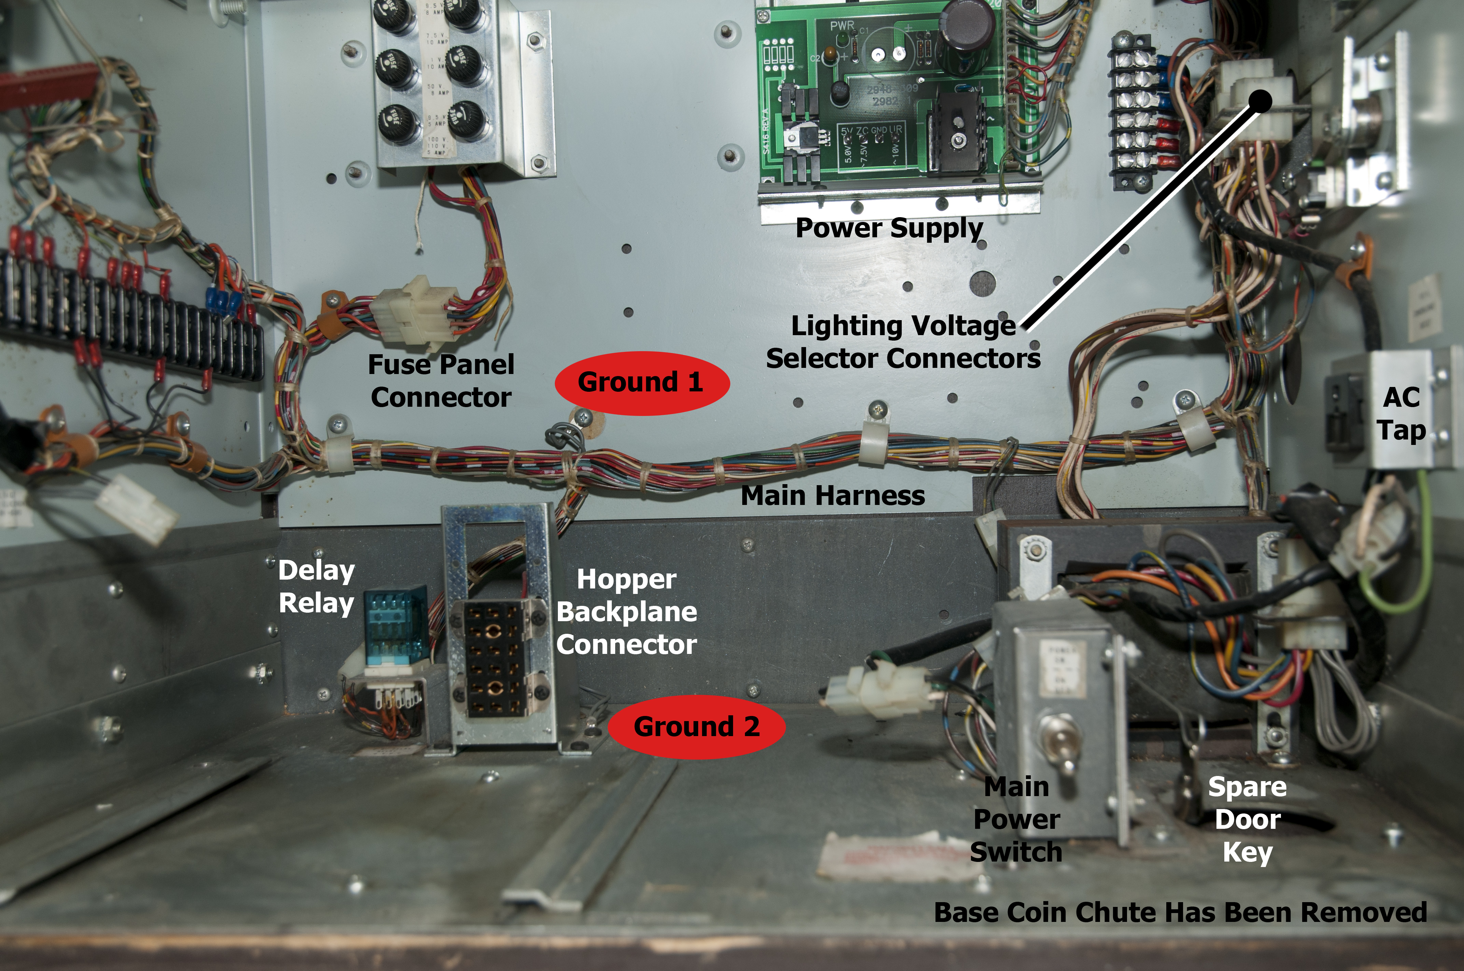
In this view, you can see the internal wiring harness and its connections. Note that the coin hopper has been pulled out to show the detail here. Fuse panel is above, and completely accessible. The Main Power Switch turns controls all power to the internals of the machine and should be turned off whenever servicing the machine.

Coin hopper shown here is responsible for delivering winning coins to the coin tray outside of the machine. Coins are laying in the hopper and when the CPU calls for coin payout, a motor rotates the coin wheel, causing coins to be lifted to the top, past the coin switch, and out of the payout slot. The three or six point rubber agitator helps lift the coins out of the hopper and on to the path that allows the coin switch to count each coin as it passes thru the slot.

More About Your Slot Machine
The door key for your machine should be kept in a safe place. Your slot machine was furnished with two keys; one that you were given when you purchased the machine, and another spare that's inside the machine, but accessible from the outside. It was put here as an emergency spare.
Open the front door of your machine, and look inside, to the right of the main power switch:
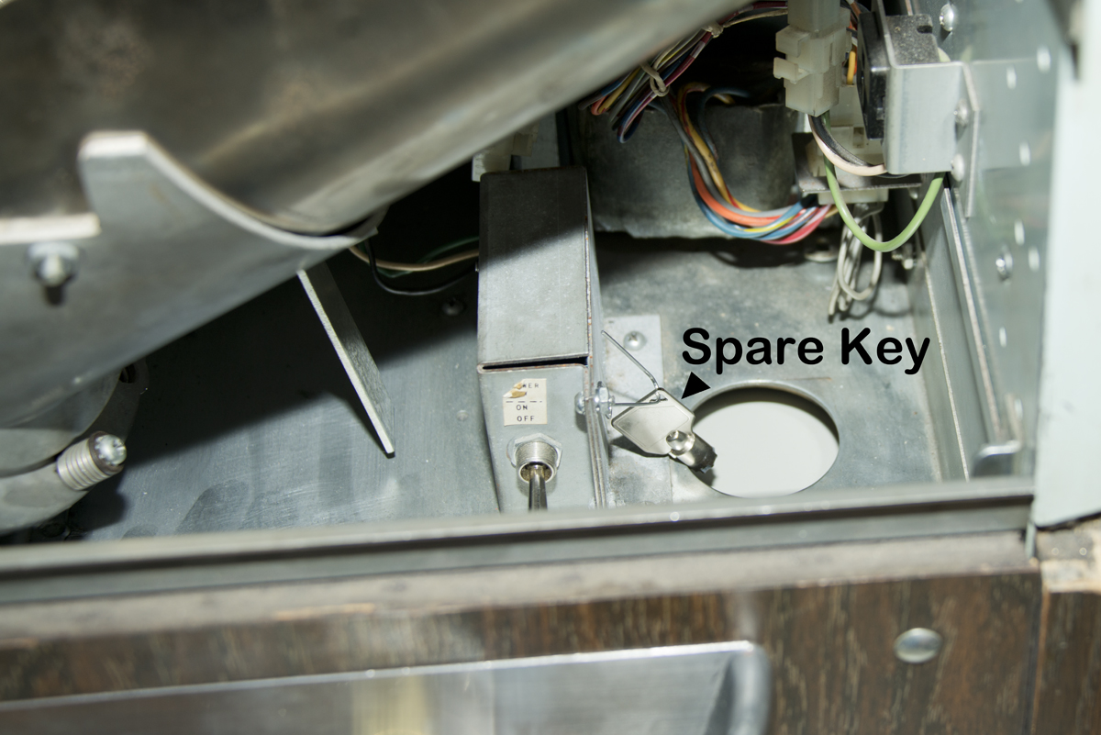

The spare door key is held in with a paper clip attached to one of the screws that hold the main power switch box cover. To access this key, you will need to slide the machine partially of its stand being VERY CAREFUL not to tip the machine. Reaching through the round hole under the base, you can retrieve this key. Keep it there though, as someday you will need it.
There is another key switch on the right side of the cabinet, behind the pull handle. This was installed by Bally to allow the casino operator access to "audit" codes that are stored in the MPU memory. These audits provide slot operation history which is unnecessary for home use. Since there is really no need for this information, we don't supply the key for this switch. Of course, if you feel the need for functionality, the lock and key is available from a locksmith shop.
The slot machine illustrated here is a conventional Bell-Orange-Plum-Cherry machine. Other styles have single, double, triple bars with 7's as the big win. The payback percentage on these slots vary from around 85% to 94%, so your coins-won vs. coins-played will keep your interest, and return most of your coins. However, at any time, the big payout can happen; its chance of happening is entirely random. Caspers Amusements offers several different, refurbished, casino slots and can also customize your particular slot machine. For example, if you're a car fanatic, Caspers offers customized reel strips and belly glass images. Suppose your all-time-favorite car is a '63 Corvette; the belly glass can have an image of that car (could be your own vehicle) and the winning reel symbols would be replaced with your favorites. An example: Your Corvette image replaces the 7's, your last hot rod image replaces the 3-bar symbols, your family car replaces the 2-bar symbols, your high school ride would replace the 1-bar symbols, and the blank spaces (every other stop) win nothing. Or, suppose you're an avid fisherman; the belly glass has a picture of you and your boat. Then the symbols could different "best catch" fish, favorite lures or tackle, and so on. Thinking along those lines, the symbols can be anything you can imagine. Caspers Amusements can customize the machine to your liking to fit your cave, garage, game room, or even trade show displays, etc.
The above mentioned trade show display can be a tremendous attention-getter. It can work this way: Suppose your company supplies tools. You display your goods at a trade show, and usually give away trinkets such as pens, tee shirts, flashlights and other items with your company logo on it. We can set up your machine to match specific give-aways. For example, a single bar 3-reel match will “win” the player a functional keychain flashlight, double bar 3 reel match will win a tee shirt, and triple bar 3-reel match will win a tool kit. Then we can set up the jackpot 7’s to win a prepaid Visa gift card or similar. The bars, sevens and cherries on the payout glass can be substituted with images of your giveaway products, and the belly glass can be an aerial view of your company as an example.
We can also imprint custom quarter-size tokens with your company logo and website which can be given to prospective players to try and win a prize. They double nicely as business cards and the recipient will remember your company when they receive the token.
Portions of this document Copyright ©Bally Gaming, Inc. Copyright ©2013 Caspers Amusements, div. of Caspers Electronics, Inc. All rights reserved.

