Symbol Binary | Left | Center | Right | NOTES
25 | ● | ● | ● | Top of strip – right strip
24 | 4 | ● | 4 | Top of strip – center strip and left strip
23 | ● | C | ●
22 | 1 | ● | 2
21 | ● | 1 | ●
20 | 2 | ● | 1
19 | ● | 2 | ●
18 | 3 | ● | 3
17 | ● | 4 | ● | 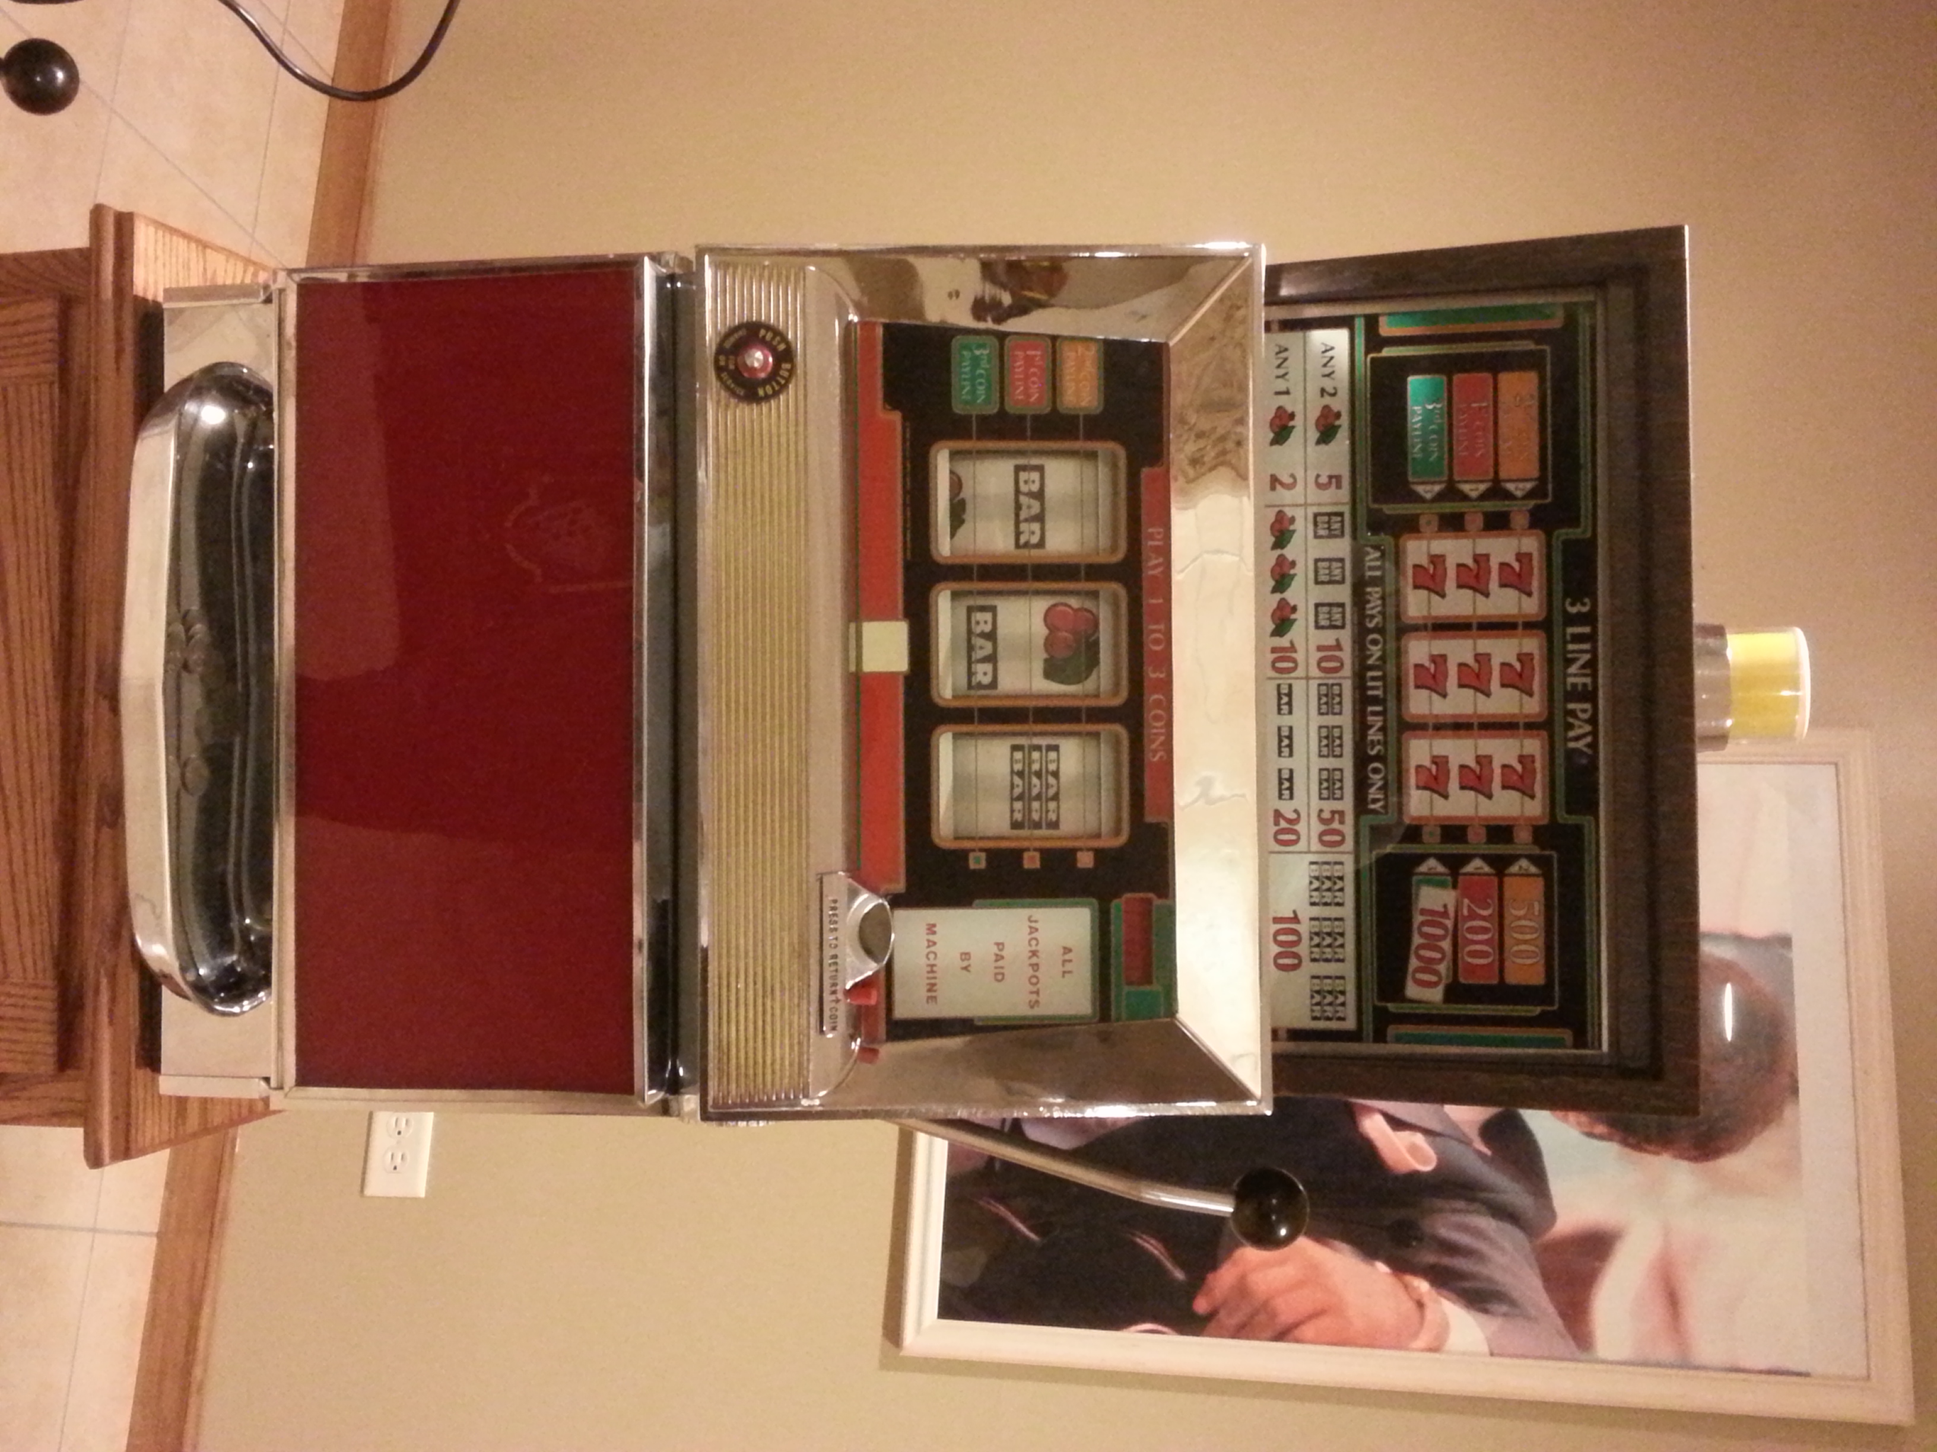
16 | ● | ● | ●
15 | 1 | ● | C
14 | ● | 3 | ●
13 | C | ● | 1
12 | ● | 1 | ●
11 | 1 | ● | 3
10 | ● | 2 | ●
9 | ● | ● | ●
8 | 3 | ● | 1
7 | ● | C | ●
6 | 1 | ● | 2
5 | ● | 1 | ●
4 | 2 | ● | 1
3 | ● | 2 | ●
2 | 1 | ● | 3
1 | ● | 1 | ● | Bottom of strip
Machine Model  E-2224-30-2 |  | M1 |  | M2 |  | M3 |  | P1 |  | P2
 |  | E755-80 |  | E755-47 |  | E755-48 |  | 450489 |  | ---
Symbol Values
Original Strip | Single Bar = 1 |  | Double Bar = 2 |  | Triple Bar = 3 |  | Cherry – C |  | Blank = ● |  | 7’s =4
New Layout
This machine is a narrow body, 25-stop, 3-line pay, 3-coin
Set strip into reel bottom first; rotate reel downwards, top of strip will overlap bottom. Length of strip:___________
1
25
X

Top of reel strip is binary Bottom of strip is binary Strips are wide s Strips are narrow

