Symbol Position | Left | Center | Right | NOTES
25 | - | - | -
24 | - | - | -
23 | - | - | -
22 | 7 | 7 | 7 | Top of strip ON ALL THREE REELS
21 | B | 1 | O
20 | BC | O | P
19 | B | 1 | C
18 | P | C | O
17 | B | 1 | P | 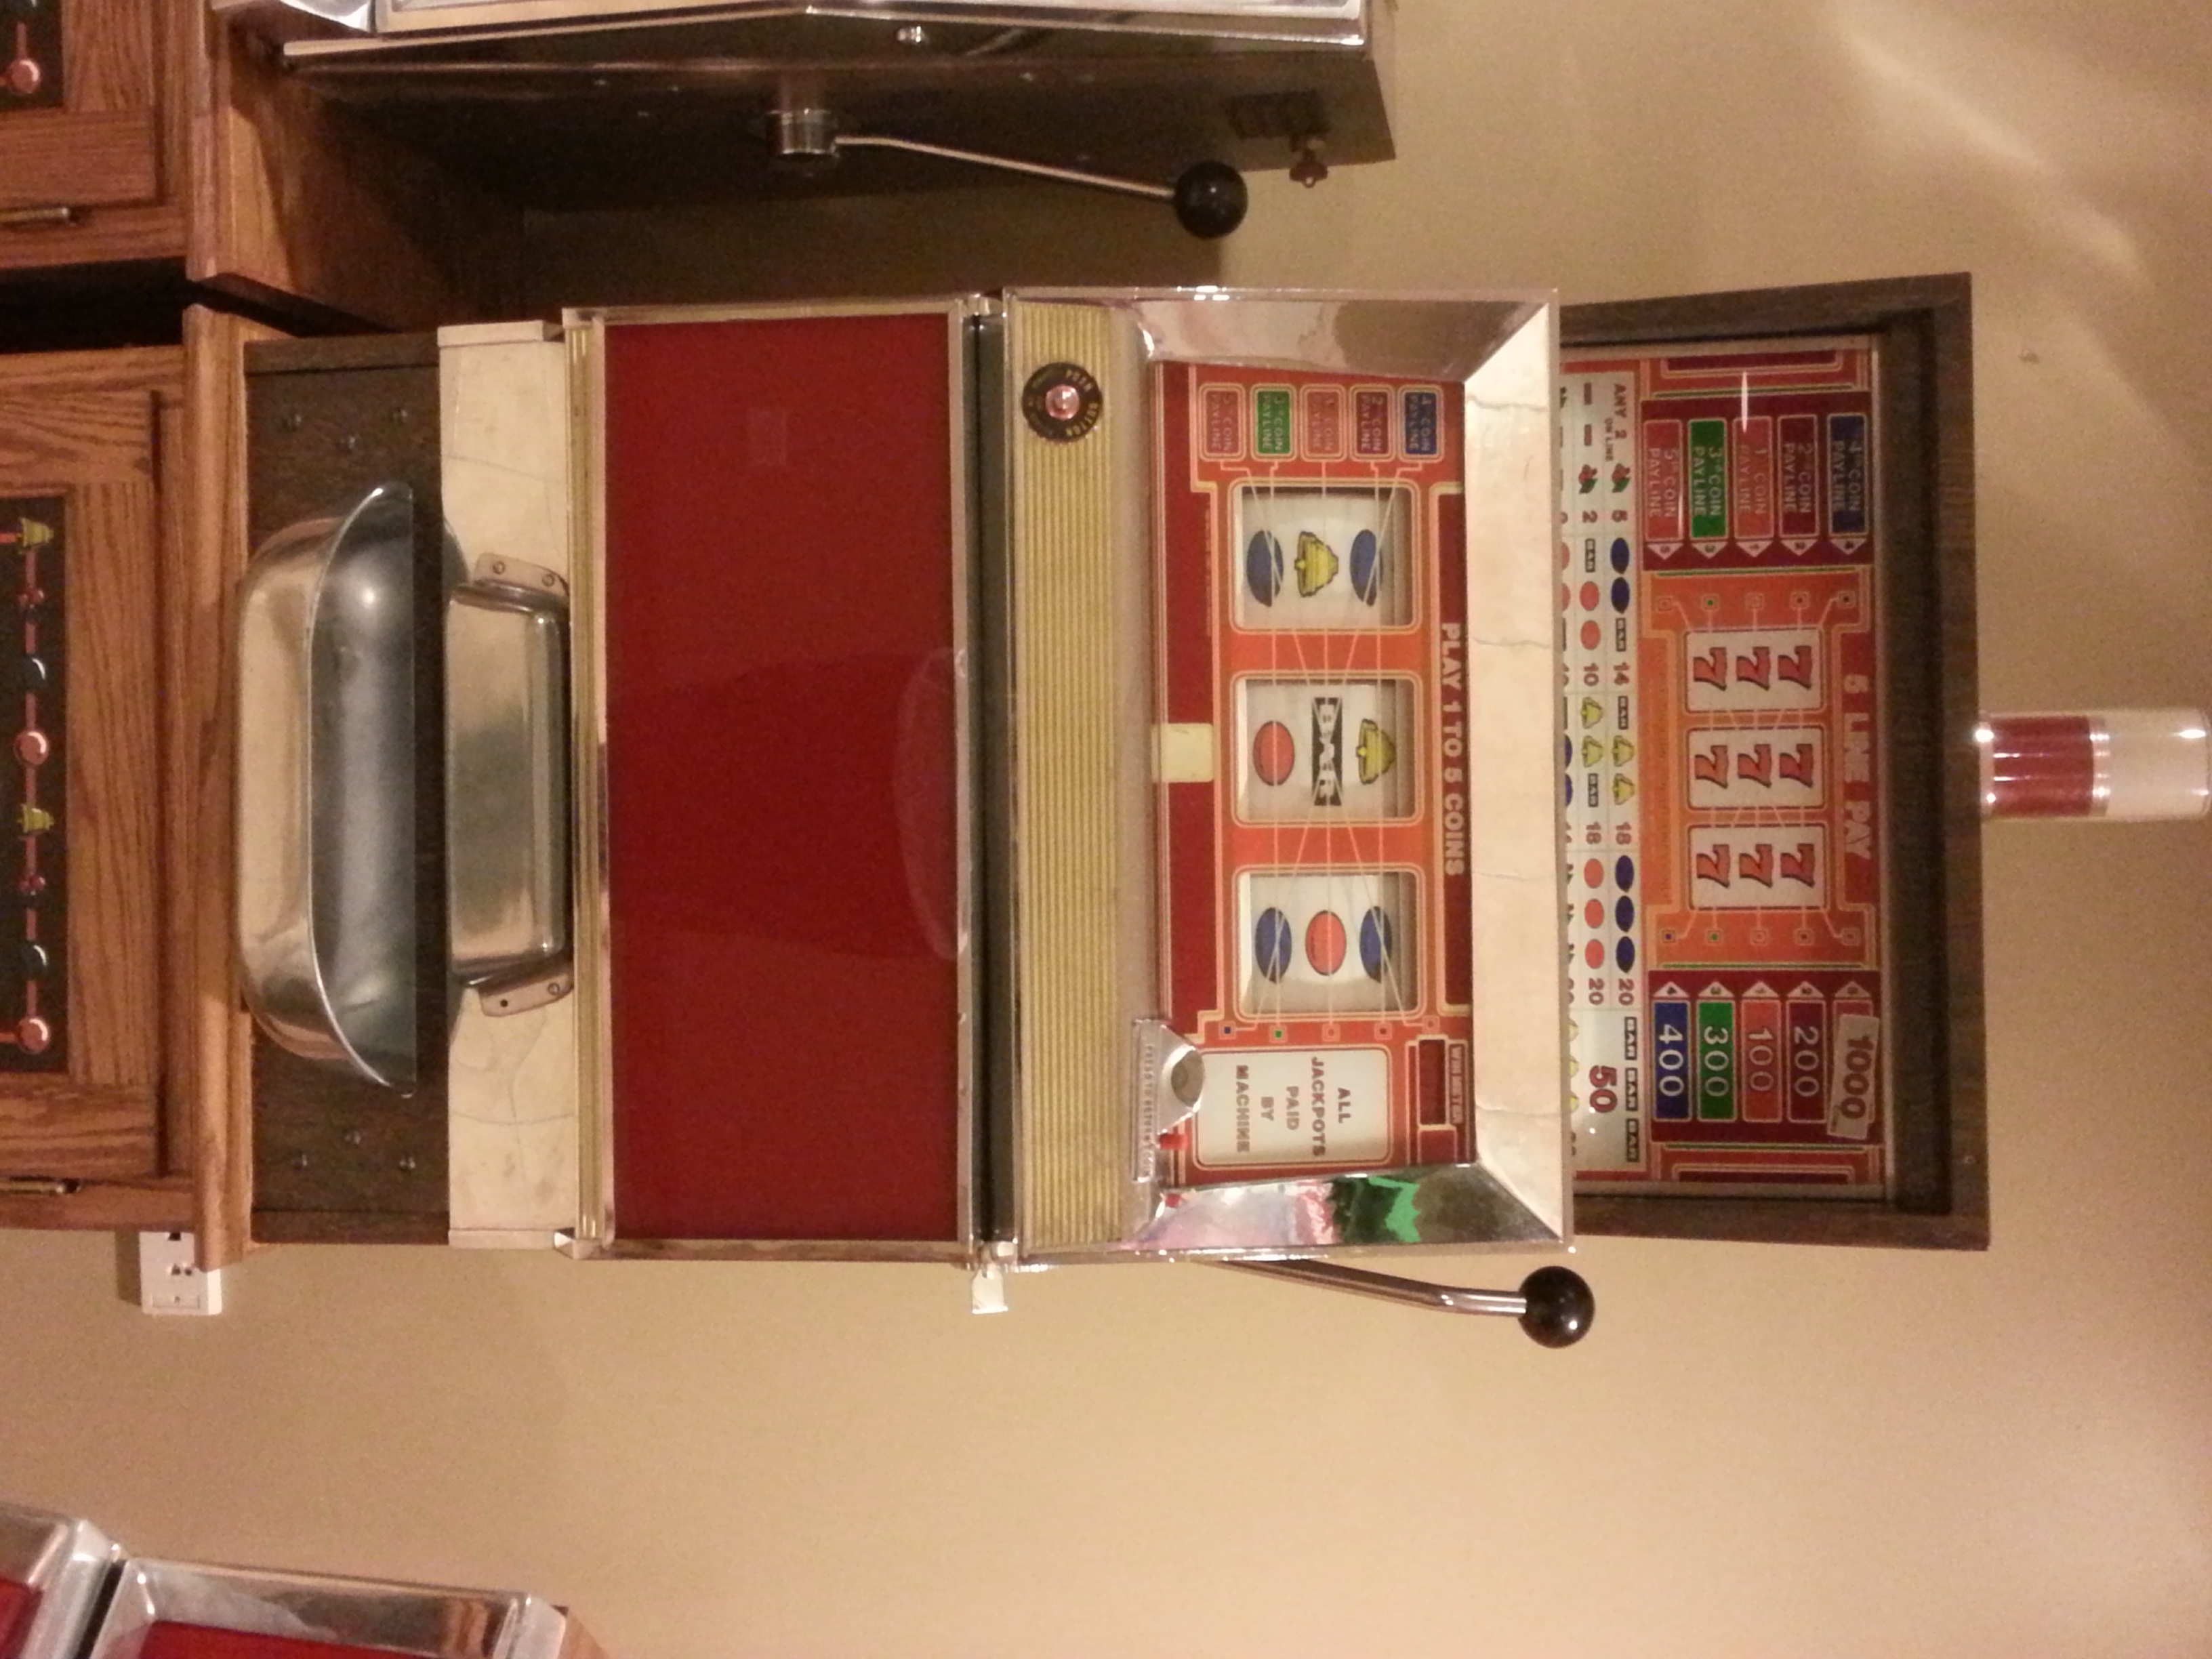
16 | O | O | O
15 | B | 1 | P
14 | P | O | B
13 | B | 1 | O
12 | 1 | B | P
11 | P | O | O
10 | B | 1 | P
9 | C | C | O
8 | B | 1 | 1
7 | P | O | O
6 | B | 1 | P
5 | P | P | C
4 | B | 1 | O
3 | P | B | P
2 | B | 1 | O
1 | P | O | P | Bottom of strip
Machine Model  E-2272-41-22 |  | M1 |  | M2 |  | M3 |  | P1 |  | P2
 |  | E755-80 |  | E755-47 |  | E755-102 |  | 583784 |  | 003701-af00
Symbol Values
Original Strip | Bell - B |  | Orange - O |  | Plum - P |  | Cherry – C |  | Bar - 1 |  | 7’s = 7
New Layout
This machine delivered to Mark Hohs on Dec. 14, 2013. 5-line, 3 coin, 22 stops

Set strip into reel bottom first; rotate reel downwards, top of strip will overlap bottom. Length of strip In. Lg.
22
1
X

Top of reel strip is binary Bottom of strip is binary Strips are wide s Strips are narrow

